What separates the ninja from the other characters is that the ninja’s mechanics do not interact with the level design; the ninja gives up versatility for agility.

The Ninja uses a Whip, that acts almost as a grappling hook. The spike at the end of the whip can pierce through walls and platforms, giving him extra moment towards the object or momentarily hang on an object.

Concept art: The ninja character will be the same age of Eloise (around 18?) and will have a art style centric to the Japanese culture we’ve structured the other character designs from. In the future Capri will post concept art for us, but as of now this is what we have to go off of.

I advise starting with FAN GIRL or Eloise because we have solid concept art of what they will look like and therefore, sound like.

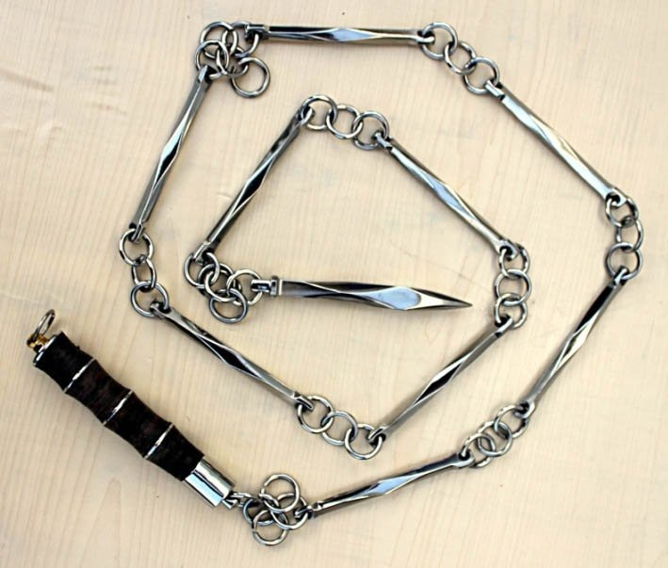

The mechanics of the Ninja include the following:

Free Mechanic: Double Jump

First Mechanic: A Dash

Second Mechanic: Grapple Hook

Third Mechanic: TBA